​​Linux

Lab 1: Manage files and directories
- Create, copy, move files and directories, use tree, locate command.
- Show the full path name of your home directory.
- Change permission file/directory (read, write, execute).
- Compress, extract files and directories with zip, tar, 7z, …
- Edit file by vim, nano.
- Use winscp transfer files from other machine to Ubuntu.
Lab 2: Managing software, system and network
- Using apt, apt-get, dpkg, … manage package update, install, remove software (nginx, apache2, sql, …).
- Managing system (task, service, …) use tool: ps, top, htop, kill, grep process.
- Managing network (IP, port, display network, domain, …) use tool: netstat, …
Lab 3: Shell Scripts / Bash scripting
Assignment 1: Comparing numbers
Given two integers. Exactly one of the following lines:
- X is less than Y
- X is greater than Y
- X is equal to Y
Input Format: Two lines containing one integer each (and respectively).
Output Format: Exactly one of the following lines:
- X is less than Y
- X is greater than Y
- X is equal to Y
Sample Input
- Sample Input 1
5
2
- Sample Input 2
2
2
- Sample Input 3
2
3
Sample Output
- Sample Output 1
X is greater than Y
- Sample Output 2
X is equal to Y
- Sample Output 3
X is less than Y

Assignment 2: Calculate the math expression
A mathematical expression containing +, -, *, ^, / and parenthesis will be provided. Read in the expression, then evaluate it. Display the result rounded to decimal places.
Constraints
All numeric values are <= 999.
Sample Input
- Sample Input 1: 5+50*3/20 + (19*2)/7
- Sample Input 2: -105+50*3/20 + (19^2)/7
- Sample Input 3: (-105.5*7+50*3)/20 + (19^2)/7
Sample Output
- Sample Output 1: 17.929
- Sample Output 2: -45.929
- Sample Output 3: 22.146
Objectives
- Use bc to compute the math.
- Use scale to change the numbers of decimal of the output.
- Write scripts that treats math expression as input.

Assignment 3: Unique number(s)
There are integers in an array. All but one integer occurs in pairs. Your task is to find the number that occurs only once.
Input Format
The first line of the input contains an integer, indicating the number of integers. The next line contains space-separated integers that form the array.
Constraints
% (is an odd number)
Output Format
Output, the number that occurs only once.
- Sample Input 1
1
1
Sample Output 1
1

- Sample Input 2
3
1 1 2
Sample Output 2
2
- Sample Input 3
5
0 0 1 2 1
- Sample Output 3
2

Lab 4: Ansible - Installing web service on a remote server
Using Ansible to install web service on a remote server.
- Web Service can be one of these: Apache2, nginx
- Separate components into files (e.g: `inventory` for list of remote servers, `playbook.yaml` is for the steps to install, …)

Lab 5: Terraform - Using Terraform to setup and create Docker container
Using Terraform to setup and create Docker container on local machine.
- Docker must be installed before you can process the assignment.
- Terraform must be installed before you can process the assignment
- Create a nginx image
- 80 is the internal port number / 8000 is for the external

AWS

Lab 1: AWS IAM
- Set up your account
- Set up MFA for your account
- Navigate through AWS Console on web to get use to the UI
- Try to create a user, create it with a prefix fadevops81<yourshortname>
- Login into that account, try to play with editing policy permission for that user to be able/unable to view EC2 instances.
- Create a group with a prefix fadevops@lgr<yourshortname>
- Add the user fadevops@1<yourshortname> to the group. And try adding permission to this group
- Remove the user, group, policy you created.
- Setting up aws cli on your local machine
- On your main AWS account, create Security Credentials and use that to finish setting up the aws cli. Verify the authentication by running some commands.
- Use Terraform with the security credential you created on step 9 to set up a EC2 instance of type t2.micro on region Singapore (ap-southeast-1)
- On the EC2 instance, install the aws cli (But do not attach any secret credential to it)
- Create a service role for EC2 that allow to list all s3 buckets
- Attach that role to EC2 and verify that the EC2 able to use the role by using aws cli command to list s3 bucket
- Now try to add another policy to the service role that will Deny all actions 3. Now can the EC2 list $3 bucket?

Lab 2: Set up terraform template and AWS VPC
- Understand the terraform template we will use throughout the whole course (template created by ThangTD18)
- Setting up environment
- Create lab file named lab02.tf
- Create:
- common_module folder
- main.tf in folder /main_logic
- lab02.tf in the folder /lab_var
- Using Terraform to create a common module for ec2 and call that module from main.tf
- In the lab02.tf var file, we will declare the variable to bootstrap ec2 instances
- t2.micro
- user-data script for nginx configuration
- Make sure the network configured correctly and check nginx landing page from public internet
- Verify the result and capture the screen
- Try to create an AMI from the EC2 and launch another EC2 instance with that AMI using AMS console. After finish then terminate the EC2 instance (The one created in this exercise)
- Try to attach an EBS volume to the EC2 created in step 4.
- ssh into the instance
- configure volume to format and mount the volume to the path /mountedvolume.
- type of -h then capture the result
- Create a common network module with these requirement:
- Input variable to the nodule: VPC CIDR
- Resource created by the module
- VPC
- 1 Internet gateway
- 1 NAT gateway
- 2 public subnets with their route tables
- 2 private subnets with their route tables
- Then call the network module in the main.tf
- Add the configuration value for network in the lab02.tf file to create a network with CIDR: 18.0.8.0/16
- Create 2 another EC2. 1 in the public subnet, 1 in the private subnet
- Try to SSH into the EC2 in the private subnet
Lab 3: Using terraform to setup an S3 bucket and host static web app using this bucket

Lab 4: Using template in lab 2 to create full infrastructure with auto scaling group and load balancer

GCP

Lab 1: Compute Engine and IAM
Use gcloud command to do following tasks:
- Compute Engine
- Set up a VM with a boot disk (size: 10 GB) and a public IP
- Create a persistent disk and attach to the VM
- Try create new VM and recover data using snapshot from previous created persistent disk
- IAM
- Create a service account, then download the service account key file
- Grant the service account the appropriate permissions to upload file to the GCP bucket
- Use the service account key file to authenticate to Google Cloud APIs and resources, then upload some files into GCP bucket
Lab 2: VPC
Follow these instructions:
- Creating a VPC
- Creating Subnets: range=10.0.0.0/24
- Creating Firewall Rules:
- Allow SSH Access
- Allow HTTP Access
- Creating a Virtual Machine in the Subnet:
- Connecting to the VM
- Testing Connectivity:
- Inside the VM, test connectivity to external resources
- Test connectivity to the VM from external resources using its external IP
Docker & Kubernetes

Docker Lab 1: Write docker command for following instructions
- Check docker version
- Search docker images on Docker Hub
- Pull nginx latest image from Docker Hub
- Show list image on local
- Run docker container in detach mode and mapping to port 8080 of local machine
- Check running containers
- Check all containers (include not running containers)
- Stop a container
- Start a container
- Remote to a running container or run a command in a running container
- Tagging a docker image
Then, finish following task:
- Create your own Docker Hub account
- Create repository
- Push nginx image to your repository
- Delete nginx image in your local machine
- Try to pull the nginx image from your repository

Docker Lab 2: Build custom docker images for nginx, tomcat, NodeJS
Task 1: Build nginx image
- Write Dockerfile to build a nginx image from ubuntu/centos/redhat/oraclelinux/alpine base image
- Create a html file on your local machine and copy to your image
- Push image to your repository
- Run nginx container from your image
- Test curl from your localhost
Task 2: Build tomcat image
- Write Dockerfile to build a tomcat image from ubuntu/centos/redhat/oraclelinux/alpine base image
- Push image to your repository
- Run tomcat container from your image
- Test curl from your localhost
Task 3: Build NodeJS image
- Write Dockerfile to build a NodeJS image from ubuntu/centos/redhat/oraclelinux/alpine base image
- Push image to your repository
- Run NodeJS container from your image
- Test curl from your localhost

Docker Lab 3: Use docker-compose to deploy a mini full-stack web app
Task 1: Install docker-compose
- Install docker-compose following this reference: https://docs.docker.com/compose/install/
- Test the installation
- Run command docker-compose version to check version of docker-compose
- Run command docker-compose –help to see the cli references
Task 2: docker-compose quick start
- Using Docker Compose to easily run WordPress in an isolated environment built with Docker containers
- References: https://docs.docker.com/samples/wordpress/
Task 3: Doing a real project including NodeJS and MySQL using docker-compose
- Create Dockerfile for building NodeJS and MySQL container image
- Create docker-compose file to running NodeJS and mysql service, connect to MySQL service from NodeJS service
- Display web page on your browser

Docker Lab 4: Do following tasks
Task 1: Experiment Volume mount
- Create a volume named task1-volume
- Run a nginx container with the volume created in step 1
- The mount point for container in /opt/mount_point/
- Use docker exec command to log into container, create a file with random content in /opt/mount_point/
- Run a second nginx container with the same mounting point as the first nginx container
- Use docker exec command to log into the second nginx container, check if the file created before is in /opt/mount_point/
Task 2: Experiment Bind mount
- Create an index.html file with the content you preferred
- Run a nginx container map to port 80:80
- Using bind mount to mount a location of your index.html file to /usr/share/nginx/html in the container
- Check if the web content is the content of your html file.
- Try modifying the content of index.html file in the container, check if the content of index.html file in your host also change

Kubernetes Lab 1: Introduction into Kubernetes architecture and kubectl commands
- Create two namespaces: dev and prod
- Apply a resource quota to the dev (2 CPU, 2Gi Memory) and prod (3 CPU, 3Gi Memory) namespace to limit CPU and memory usage
- Create a Deployment with nginx image with multiple replicas in the dev namespace
- Create a Deployment with custom image (image pushed on Dockerhub in Docker lab) with multiple replicas in the prod namespace
- Observe the Pods created in the dev and prod namespace using kubectl get
- Observe the events of pods using kubectl describe
- Make sure pods are up and running

Kubernetes Lab 2: How to use Kubernetes’ services
- Create a nginx deployment with 3 replicas
- Create service type ClusterIP for nginx deployment
- Create a new app and test the connection to above nginx deployment using:
<service name>.<namespace>.svc.cluster.local
- Create a service type NodePort. Try to access the application from browser
- Create a service type LoadBalancer. Try to access the application from browser

Kubernetes Lab 3: Big Lab – Create a Kubernetes cluster with following requirements:
- Deploy 3 pods to run Front-End services (ReactJS, VueJS, Angular, etc.).
- Deploy 3 pods to run Back-End services (C#, Java, Golang, Python, etc.).
- The images for Front-End and Back-End must be built from Dockerfile and pushed to Dockerhub (default images from the Docker registry should not be used)
- The pods should auto-scale based on CPU usage.
- Deploy a database (MySQL, MongoDB, etc.) with the option to implement a High Availability (HA) model using Helm or StatefulSet (bonus points will be awarded).
- Configure the Front-End to call the Back-End, and the Back-End to call the database.
- Store relevant credential settings in Secrets.
- Use DaemonSet to deploy ElasticSearch (using the fluentd-elasticsearch image) or complete EFK stack or any kind of logging and monitoring stacks.
- Deploy an Ingress to allow access to the Front-End service from the internet using a DNS. Configuring HTTPS is a bonus point. If a domain name is not available, use either NodePort or LoadBalancer service type (maximum points will not be awarded).

Azure

Lab 1: Provision Virtual Machine, Resource Group using Azure CLI, Bicep (ARM Template), Terraform
- Resource Group
- Virtual Network
- Subnets
- Network Interface Cards
- Network Security Group
- Virtual Machine

Lab 2: Provision following infrastructure using Azure CLI / Bicep (ARM Template) / Terraform
Reference: Implement Network Traffic Management (github.com)
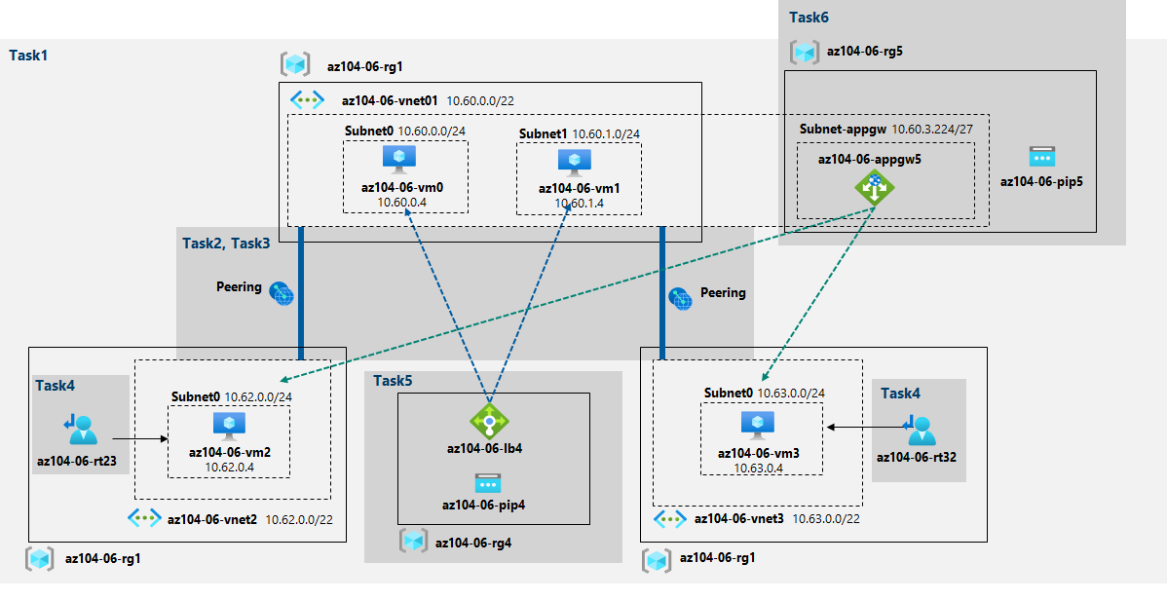

Lab 3: Implement Automation Renew Certificate TLS/SSL for Azure Application Gateway
Reference: Automating Azure Application Gateway SSL certificate renewals with Let’s Encrypt and Azure Automation (intelequia.com)
PowerShell script in reference used module ACME Sharp which was outdated
You must try to refactor the script to use up-to-date modules like ACME-PS, Posh ACME (in PS 5.1 / 7.1)
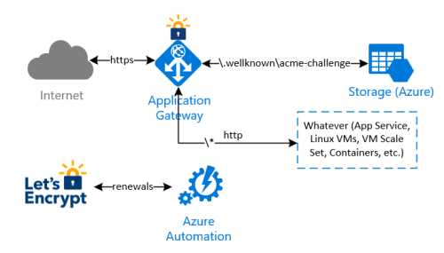

Lab 4: Implement simple CI/CD with Azure DevOps and Azure App Service

CI/CD

Lab: Create complete CI/CD pipeline

Pipeline components
- Git
- Terraform
- GitLab CI / Jenkins / Cloud native CI/CD tools / …
- Ansible
- Docker
- Cloud providers: AWS, GCP, Azure
- Prometheus
- Grafana
Expectation
- Everything works aka the website / backend / database.
- Diagram for the system that you are trying to build.
- The pipeline can handle the update process.
- You guys should be able to do the first tick (ü) – the basic option for every component.
- Any ‘Not basic’, ‘Not so basic’, or other options rather than the basic one is considered as bonuses.
Preparation
- Slides including requested design diagrams
- Source code (this should be pushed to our private GitLab repo)
- Video (showing your lab and the process)
- Confident
- Note: You can copy code or ideas from anywhere on the Internet, but we expect you to ask every question about your lab. If you cannot, we’ll assure you this’s not your job.

